THE LIFE AND MUSIC OF LUDWIG VAN BEETHOVEN
(17th December 1770 – 26 March 1827)
Introduction
This short essay will provide the reader with a general insight into the life and a selection of masterworks created by the German composer Ludwig van Beethoven.
Born in the city of Bonn on 17th December 1770, Beethoven was one of the greatest and best-loved promoters of German orchestral music the world has ever known, being instrumental in musical arrangement shortly after the arrival of the Classical period of Western Art music.
This paper will investigate the following key areas:
- Beethoven’s early life, with a view to his creativity in piano performance.
- His subsequent move to Vienna for the purpose of meeting contemporary composers living and working in that celebrated musical city.
- The unique Sketchbooks.
- The exclusive Conversation books.
- Catalogue of selected Beethoven works.
- The influence of Western Art Music on musical aficionados both past and present.
Early life
The encouragement and expert knowledge from his father Johann inspired the young Beethoven to take an active interest in the art of composition from a very early age, the experience of which set the stage in adult life for an extensive range of creative studies, these being recorded as below:
- Compositions for piano, violin and cello (mostly arranged in the form of concertos and sonatas).
- A selection of 10 well-structured concert overtures & 1 operatic overture.
Composed over a 24-year period (1800 – 1824), these ever- impressive orchestrations serve to demonstrate the development of Beethoven’s melodic state of mind.
- Nine symphonies.
- Chamber and vocal works, piano and string trios.
- The Creatures of Prometheus ballet score (1801).
- Fidelio: 2- act opera. (1805).
- Missa Solemnis, Mass in D major, (1819 – 1823).

Following training in both piano performance and musical creation, the skills of which were quickly discovered by taking lessons from fellow German opera composer and conductor Christian Neefe , the young Beethoven quickly became an established pianist, presenting his first ever public concert performance in Cologne at the age of just 8, with countless more compositions to follow in later life.
Vienna
Whilst living in Bonn in the year 1787 at the age of just 17, Beethoven received paid leave of absence to visit Vienna for the sole purpose of making studies in musical composition.
It was in this great musical city that Beethoven met the composer who would become a tremendous influence on his future music career –none other than Wolfgang Amadeus Mozart (1756 - 1791).
Mozart’s musical arrangements quickly became an immense inspiration to the 17-year-old Beethoven, providing much encouragement for his own compositional material, especially so in the form of piano concertos, string quartets and future symphonic works.
However, 2 months after his arrival in Vienna, Beethoven’s mother became ill from consumption, and following her bereavement on 17th July 1787, the young Beethoven returned to his home city of Bonn.
However, later that year, Beethoven was once again living back in Vienna, only this time he was in receipt of substantial music lessons from the Austrian composer Joseph Haydn (1732 – 1809) in the following musical categories: Form, Rhythm, Melodic style, Dynamics, Instrumentation and Chord progressions.
So, once again Vienna became Beethoven’s musical residence, with the everlasting spirit of Haydn and Mozart by now firmly preserved in his memory.
It was only three years later that the wonderful talent of Beethoven would receive not only great admiration, but full recognition for his outstanding performance in the art of improvisation.,,,
Eroica symphony
In the year 1805, Beethoven looked for new discoveries in his compositional arrangements, the result of which guaranteed the production of his third symphony, the most celebrated and respected Eroica.
Originally written in honour of the French political and military leader Napoleon Bonaparte, who rose to high prominence at the time of the French Revolution, this symphonic work is considered to be one of Beethoven’s finest musical products.,

Sketchbooks
Beethoven became a well-known lover of both nature and the environment, and many of his musical arrangements were based on personal notes, these being compiled during the composer’s frequent walks in the countryside.
The Pastoral symphony is just one and possibly the best of many fine examples of Beethoven’s outdoor and geographical experiences.

The Pastoral symphony
Completed in 1808.
In reference to the Austrian countryside, this being the area where Beethoven loved to walk, and as such inspired the composer to develop many of his composition outlines that were subsequently included into his symphonic works, the subject matter of the Pastoral symphony is primarily based on “recollections of country life”.
Beethoven would carry with him loose sheets of paper for the purpose of recording ideas he developed whilst following his walking route. For example, he would hear the beauty and varied sounds of the woodland, the likes of which would be most likely to include the tweet of birds, the trickling of streams, and the rustling of leaves.
A gradual stage - by - stage process would eventually transform these conceptions into a future masterpiece, serving to demonstrate the brilliance of Beethoven’s creative mind within the popular art of composition.
Following the first 2 movements, a particular interest develops towards the end of the third movement, where a combination of cellos and double basses are introduced to portray a series of threatening clouds, the music progressively giving way to the developing stages of an approaching storm that is featured in the fourth movement, after which the fifth and much calmer final movement brings the symphony to a peaceful ending.
Beethoven quote:
In Beethoven’s own words, written in 1810...
“How delighted I will be to ramble for a while through the bushes, woods, under trees, through grass, and around rocks. No one can love the country as much as I do. For surely woods, trees, and rocks produce the echo that man desires to hear”.
These words not only sum up the magnificence and skill in the writing of the Pastoral symphony, but they were actually part of a farewell letter that Beethoven wrote to Therese Malfatti, an Austrian musician who the composer unsuccessfully courted. He also dedicated to this lady the solo piano work bagatelle number 25, commonly known as ‘Fur Elise’, published in 1867.,,
So, before we hear the music, the symphony serves as a shining example of how a single idea can be identified and represented through the lens of musical arrangement.

THE 5 MOVEMENTS OF THE PASTORAL SYMPHONY:
1st movement: CHEERFUL FEELINGS UPON ARRIVAL IN THE COUNTRY.
The first movement is characterised by countryside melodies, these being based on short musical themes made possible by a careful selection of appropriately used instruments.
2nd movement: SCENE BY THE BROOK.
A developing theme, and one which is representative of nature emerges towards the end of the movement, played on the clarinet and designed to imitate the sound of a cuckoo.
3rd movement: MERRY GATHERING OF PEASANTS.
A mighty thunderstorm is due, but before its actual arrival, enjoyable country-dance music can be heard in this movement.
4th movement: A VIOLENT STORM.
In this movement, Beethoven describes the developmental phases of a great storm, making use of a range of instruments, these being cellos, double basses, violins, timpani and flutes, all of which are designed to portray the falling of raindrops in advance of a vigorous weather pattern, subsequently creating a scene that illustrates the never-ending struggle with nature.
^{5th movement: SHEPHERDS’ HYMN}
With the passing of the storm, the natural cycle of living creatures begins to appear once again.

Conversation books
By 1816, Beethoven was beginning to have difficulty with his hearing, which, when exacerbated by occasional spells of depression, eventually encouraged the composer to keep a series of notebooks as a means of communication with friends and other associates.
These essential and well-preserved records originally appeared in the form of manuscripts, but sadly only 136 such documents survive today, these being currently preserved in the Beethoven–Haus museum in Bonn.
These highly significant books, which records show to have begun around the year 1818, are believed to have been Beethoven’s only contact with the outside world during the final years of his life, just at a time when his hearing became an even greater problem.
These accounts are considered to be unique historical records, the contents of which illustrate the particular technique that Beethoven would have required for his music to be performed.

Symphony No 9 (Choral)
Composed between 1822 and 1824 and first performed in Vienna on 7th May 1824, the principal feature of the Choral symphony is the well-known poem Ode to Joy, written in 1785 by the German playwright and historian Friedrich Schiller under the Germanic title of An die Freude.
The Choral symphony symbolises the magnificent achievement which resulted from the composer’s personal contribution towards the advancement of musical arrangement, an influence which prompted fellow German composer Richard Wagner to describe Beethoven as ‘A Titan wrestling with the Gods’.
This celebrated masterpiece has been beautifully researched and illustrated by several trustworthy authors, 3 of which are referenced below.,,

Quote:
Beethoven’s ‘Choral’ symphony. “His finale opens stormily, leading to agitated recitatives for the basses alone, ominous and protesting figures that are like a great voice delivering an angry speech; ghostly sections of the first 3 movements come and go like wraiths on the wind; a magnificent choralelike theme unfolds itself at length; there is a return to the stormy mood of the opening, and then the protesting orchestra is suddenly interrupted by the first sound of a human voice – a ringing challenge from the baritone that pierces the orchestral gloom like a shaft of light. Thereafter, the entire apparatus of soloists, chorus and orchestra is set in motion, publishing the various stanzas of Schiller’s poem”.

Fidelio
A Rescue Opera in 2 acts:
Have you ever heard of an opera by Pierre Gaveaux, Johann Simon Mayer or Ferdinando Paer? Those names perhaps don't sound at all familiar.
Well, the above mentioned were all quite fashionable composers in their time. In fact, a couple of centuries ago each of the 3 wrote operas featuring courageous wives who risked their lives to rescue their condemned husbands, this being a popular opera plotline in the 1800s.
A number of other composers too, such as Umberto Giordano, in his 1896 opera Andrea Chenier, have also developed a similar setting for their operas, and most of them appear just as obscure as the 3 names mentioned above.
Beethoven’s Fidelio.
Ludwig van Beethoven, with his opera Fidelio, set in Seville in 18thC Spain in the year 1805, transported the ‘rescue’ storyline into the opera house, and this brilliant drama has long since overshadowed all the rest.
Fidelio certainly falls within this rescue opera genre, this being a loosely based term that generally describes a type of opera that developed in France at the time of the French Revolution (1789-1799), and quickly became popular all over Europe.

The plot
The opera features a Spanish nobleman named Florestan, a political prisoner who is under sentence of death for exposing crimes that have been carried out by the prison governor.
Florestan’s wife Leonora enters the prison in disguise as a guard under the name of Fidelio, and subsequently makes a courageous rescue attempt to free Florestan from the prison.
In actual fact, Leonora herself becomes the leading lady of the story, firstly because she succeeds in organising the release of her husband, and secondly, she sets the scene for a temporary freedom and eventual liberation of the other prisoners, this being much to the jubilation of the crowd of observers who are standing behind the prison walls.
Success rate.
It is true to say that Beethoven’s only opera is a masterpiece. The music is excellent throughout, which includes the famous Act I Quartet, the Prisoners’ Chorus and Florestan’s impassioned Act II ‘Cry in the darkness’ and ‘Vision of hope’.
The opera brings together the dark reality of the ‘French Revolutionary Terror’ and to illuminate Fidelio’s inspiring message of shared humanity.
After several revisions and disputes with theatre management, it was the 1814 version that finally brought success for this much-loved opera.
According to political scientist John Bokina, Fidelio is a sensuous representation of a crucial era in the history of political ideas.
Quote: “the transition from the rationalistic social criticism of the earlier pre-revolutionary Enlightenment to the virtuous Republicanism of the later Enlightenment and the French Revolution”.
In conclusion, Rescue operas represent a rescuer so heroic that he or she willingly risks everything in the cause, with an outcome that signals the inevitable triumph of human will, freedom over injustice, domestic intrigue, determined love and the cruelty of an oppressive regime. Fidelio provides all this, with plenty of drama and emotion too.
And finally,
Further Beethoven facts.
Please note that the enclosed link is highly significant in that it includes some rare information on Fidelio.

Piano concertos
The 5 Beethoven piano concertos were completed between the years 1793 and 1809, with the first performance of the Piano concerto No 1 in C major taking place 18th Dec 1795 in Vienna.
Beethoven’s style and characterisation on the piano, examples of which range from beautiful cadenzas to haunting melodies, are typical of the unmistakable variations and established themes which can be heard in his music.

Piano sonatas
Moonlight sonata
The Piano Sonata No. 14 in C-sharp minor, popularly known as the Moonlight sonata, is one of the best loved in the whole repertoire of the Beethoven piano compositions.
The origins of the Moonlight Sonata can be traced back to the Berlin born music critic and poet Heinrich Rellstab (1799 -1860).
Rellstab ‘Moonlight’ Quote: “A portrayal of a moonlight setting, typically shining upon the beautiful Lake Lucerne in Switzerland”.

Pathetique sonata
Piano Sonata No. 8 in C minor, the Sonata Pathétique, was written in 1798 when Beethoven was just 28 years old, and was published the following year.
Beethoven dedicated this sonata to the Viennese born Prince Karl Alois Lichnowsky, who had associations with the Imperial Austrian court.
Violin sonatas
The violin sonatas, of which there are 10 such compositions in total, with the ‘Spring’ & ‘Kreutzer’ probably the best known of all, were written between 1798 and 1812.
Consisting of beautiful craftsmanship, these works are highly significant for Beethoven aficionados, in that they serve to demonstrate how experimentation with the violin enabled the composer to develop ways to create an equal voice alongside the piano.
For example, in the first movement of the Spring sonata, written in Allegro form, the soft violin plays the note A, allowing the main theme to subsequently unfold into an appropriately designed piano accompaniment.

Quote:
Daniel Tong on the first 5 sonatas.
Quote:
Edwin Fischer on the Beethoven sonatas: “For Beethoven, the sonata form is not a scheme that can be used in caprice one day and abandoned the next. This form dominates everything he imagines and composes; it is the very mark of his creation and the form of his thought – an inherent form, a natural one”. (“The sonata is the very characteristic of Beethoven’s creation and the form of his thought. Beethoven holds a key role in the transformation and evolution of the sonata form”).

Violin concerto
Beethoven wrote his D major violin concerto in 1806. It was performed on 23rd Dec of the same year, just 3 years after the writing of his third symphony.
The Creatures of Prometheus
The Creatures of Prometheus, composed in 1801, was the only ballet to have been written by Beethoven.
In collaboration with Salvatore Vigano (1769 -1821), an Italian composer and choreographer, the ballet is composed of two acts, featuring 16 individual numbers in total.
In comparison with the dramatically designed compositions of Beethoven’s symphonies and overtures, the Creatures of Prometheus is considered to be of a much lighter framework.

Beethoven’s loss of hearing
Many of Beethoven’s works were written whilst he was beginning suffer from difficulties in hearing, the problems of which are believed to have begun as early as 1798, by which time he was at the age of 28.
By 1801, one year after the first symphony had been composed, Beethoven had lost around 60% of his hearing.
Possible lead poisoning
This was at a time when some form of lead poisoning, high concentration levels of lead, may have been a contributing factor, examples of which may include the impact of lead- contaminated dust.
Whether or not lead poisoning was proved to be the case, further deterioration of his hearing failed to prevent Beethoven from composing musical masterpieces on an elaborate scale.

Death
On the 26th March, 1827, after signing his will and receiving the last rites of the church, Beethoven died from suspected liver damage, believed to have resulted from heavy alcohol consumption at the age of 56
In conclusion
Ludwig van Beethoven has always been associated with a rich variety of compositions, making him one of the most influential architects of endless well-established melodic creations of the late 18th & early 19th centuries.
As the Sketchbooks respectfully illustrate, many of Beethoven’s compositions were produced from a variety of wide-ranging sounds during his visits to the Viennese countryside, the result of which generated a series of splendid and outstandingly grand masterpieces of the highest quality, outstandingly the Pastoral symphony.
From the Classical tradition through to the Romantic and modern-day movements of the 20thC, he has left us with a legacy in musicology which only a limited number of composers have managed to accomplish.
Finally, Ludwig van Beethoven is without question one of the greatest advocates of musical strategy that the world has ever has had the pleasure of knowing.

Bibliography
Cooper, B, The Beethoven Compendium (London: Thames and Hudson, 1991).
Crowest, Frederick J., Beethoven (London: J. M. Dent & Co., 1903
Hogler, Fritz, W.A.Mozart (Vienna: Österreichischer Bundesverlag, 1956).
Jones, D.W The Life of Beethoven (Cambridge: Cambridge University Press, 1998).
Leonard, Richard A., The Stream of Music, 3rd edition, revised (London: Hutchinson & Co., 1967)
Levy, D.B., Beethoven: The Ninth Symphony New Haven, Conn: Yale University Press, 2003 (an imprint of Simon & Schuster MacMillan, 1995).
Lockwood, L., Beethoven: Studies in the Creative Process (Cambridge, Mass: Harvard University Press, 1992).
Mies, B., Beethoven’s Sketches: An Analysis of his style based on a study of his sketch - books. (Oxford: Oxford University Press, 1929).
Robbins, H.C., Beethoven: A Documentary Study (London: Thames & Hudson, 1970)
Scholes, P.A. Oxford Junior Companion to Music. (London: Oxford University Press, 1968). P36, Beethoven’s Sketch and Conversation books.
Sipe, Thomas, Beethoven: Eroica symphony (Cambridge: Cambridge University Press, 1998).
Solomon, Maynard, Beethoven: (London: Cassell & Colt., 1978).

Online information sources.
1. Source type: Jstor.
2. Other related articles.
3. Associated contributors.

Edwin Fischer. Former classical pianist, Lecturer & Conductor (1886-1960).

Details:

Specialist in the following composers: J.S. Bach, Mozart and the Beethoven piano sonatas.

Journal Article: Vol. 101, No. 1405 (Mar., 1960), pp. 175-176.
Information: The journal obituary column.
Source: The Musical Times.
Publication: The Musical Times Publications Ltd., 22 Gibson Square, London N1 ORD, UK
Stable URL: http://www.jstor.org/stable/948484.

Lydia Hailparn.
University: Drew university.
Address: 36 Madison Ave, Madison, NJ 07940, United States.
Related article: Exploring Cadenzas to Beethoven’s Piano Concertos.
Article information: College Music Symposium, Vol. 21, No. 1 (Spring, 1981). Article 1, pp 48-59. Article is undated.
Publication: The College Music Society, 312 East Pine Street, Missoula, MT 59802, USA.
Stable URL: http://www.jstor.org/stable/40375160
……………………………………………………………….

H. Hammelmann.
Reader please note:
The following bibliography includes only a brief mention of the author H Hammelmann.
However, for the purpose of finding more information about this author and his/her respective publications, the bibliography clearly states that pp.346-350 are not shown within the preview: https://books.google.co.uk/books?id=zgF7xN-_7SsC&pg=PA351&lpg=PA351&dq=H+Hammelmann+on+beethoven&source=bl&ots=e_cVv4jtHn&sig=ACfU3U3hAc0YDdzktHKm1zhTDDALm4N0Ew&hl=en&sa=X&ved=2ahUKEwjZw8Teqr_lAhXEoXEKHSslDOAQ6AEwEHoECAgQAQ#v=onepage&q=H%20Hammelmann%20on%20beethoven&f=false.
Journal article: Beethoven’s Conversation books.
Article details: The Musical Times, Vol. 106, No. 1465 (Mar. 1965). Article 8, pp187 – 189. DOI: 10.2307/948240
Published by: The Musical Times Publications Ltd., 22 Gibson Square, London N1 ORD, UK
Stable URL: http://www.jstor.org/stable/948240

……………………………………………………………….

Raymond Knapp.

Journal article: A Tale of Two Symphonies: Converging Narratives of Divine Reconciliation in Beethoven's Fifth and Sixth.

Author: Raymond Knapp.
Information: Academic Associate Dean and a Distinguished Professor of Musicology at the University of California in Los Angeles.
Journal Information: Journal of the American Musicological Society, Vol. 53, No. 2 (Summer, 2000), pp. 291-343. DOI: 10.2307/832010
Publication: University of California Press, Berkeley, CA, USA. Published on behalf of the American Musicological Society who are currently based in New York.
Stable URL: http://www.jstor.org/stable/832010
……………………………………………………………….

DR A. C. KALISCHER

Article: Beethoven’s Letters.

Description: A Critical Edition with Explanatory Notes, Vol 11.
Publisher: J. M. Dent & Co., London (1909).

Translator: J. S. Shedlock.

Reviewed Work: Beethoven the Letter-Writer.

Publisher: The Musical Times
Vol. 50, No. 797 (Jul. 1, 1909), pp. 451-453 (3 pages).
Published by: Musical Times Publications Ltd.
DOI: 10.2307/907544
Stable URL: http://www.jstor.org/stable/907544
……………………………………………………………
RICHARD WILL.
Article: Time, Morality, and Humanity in Beethoven's "Pastoral" Symphony.
Journal: Journal of the American Musicological Society.
Vol. 50, No. 2/3 (Summer - Autumn, 1997), pp. 271-329.
Publication: University of California Press on behalf of the American Musicological Society.
Stable URL: http://www.jstor.org/stable/831836
DOI: 10.2307/831836.

Appendices
Related Beethoven websites:
- Ludwig van Beethoven’s biography
www.lvbeethoven.com/Bio/BiographyLudwig.html

- The Beethoven collection
A full catalogue of Beethoven’s works can be found by accessing the following link:
www.classicalarchives.com/composer/Ludwig_van_Beethoven
- Beethoven – Haus museum.
Details about Beethoven’s life and the associated museum in Bonn where he was born on 17.12.1770 can be found on the following Beethoven website:
www.beethoven-haus-bonn.de/

- Fidelio

See Peter Gutmann’s extensive information on “Fidelio” at the following website.

www.classicalnotes.net/classics2/fidelio.html

- Historical Overview

A look at the connections between “Beethoven, Napoleon Bonaparte and the ‘Eroica’ symphony”, as displayed in the following website:

www.beethovenseroica.com/Pg2_hist/history.html

- Conversation Books

Brief notes on Beethoven’s Conversation Books are to be found here:

www.beethoven-haus-bonn.de/sixcms/detail.php/18568/glossar_detail_en

- Pastoral symphony

The following website includes information on Beethoven and nature.

www.classicalnotes.net/classics4/pastoral.html

- Ludwig Rellstab – German poet and music critic
See Graham Johnson’s exclusive report on the life and career of Ludwig Rellstab here:
www.hyperion-records.co.uk/c.asp?c=C1082

- Daniel Tong

Daniel Tong’s 2014 commentary on the ‘Beethoven Violin sonatas’ is included in the following website.

www.beethovenplus.com/beethoven-violin-sonatas/

- Chamber music
See the article by Frederick J Crowest on the enrichment of Chamber music by Beethoven which follows both Haydn and Mozart’s contribution to this artform.

Beethoven Interviews

- SIR SIMON RATTLE.

Date of interview: 16.10.15

Length of interview: 54 min.

Details:

Sir Simon Rattle talks to the journalist Shirley Apthorp about variations in the Beethoven symphonies, all of which were performed under his leadership of the Berliner Philharmonic orchestra during the 2015/16 season, of which he was principal conductor from 2002- 2018.

Access here: https://www.digitalconcerthall.com/en/interview/22390-2

…………………………………………………………………………

- IVAN FISCHER.

Date of interview: 28.5.2013

Length of interview: 15.17

Details:

A short interview with the Hungarian conductor Ivan Fischer in which he discusses Beethoven as a composer of the aristocracy.

Access here: https://www.youtube.com/watch?v=ZgOTVoDqZKc

HERBERT BLOMSTEDT.

This is how Beethoven can change your life – we meet the legendary conductor Herbert Blomstedt.

Interview: 20 October 2017, 16:45
Access here: https://www.classicfm.com/discover-music/beethoven-herbert-blomstedt/

…………………………………………………………………………………………………………..

- FREDERICK J CROWEST.

Beethoven:

A conducting overview from Frederick J Crowest.

Composers generally do not make good conductors and Beethoven was no exception to the rule, unlike Mendelssohn for example, who we know could conduct.

Beethoven portraits and other related images

Image 1

A portrait of Beethoven by the German painter Joseph Karl Stieler. (1820).

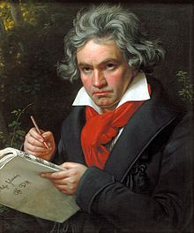

Image 2

A portrait of Beethoven by Anton Felix Schindler, an early biographer of Beethoven. (c1826).

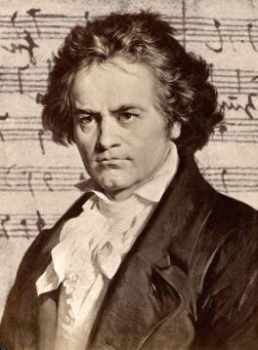

Image 3

Beethoven with Mozart in Vienna in 1787.

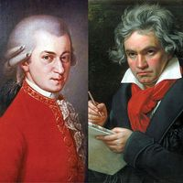

Image 4

The Beethoven – Haus (museum) in Bonn (Outside).

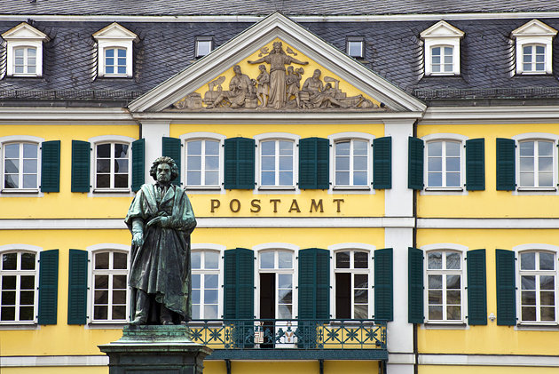

Image 5

The Beethoven – Haus Museum in Bonn (Inside).

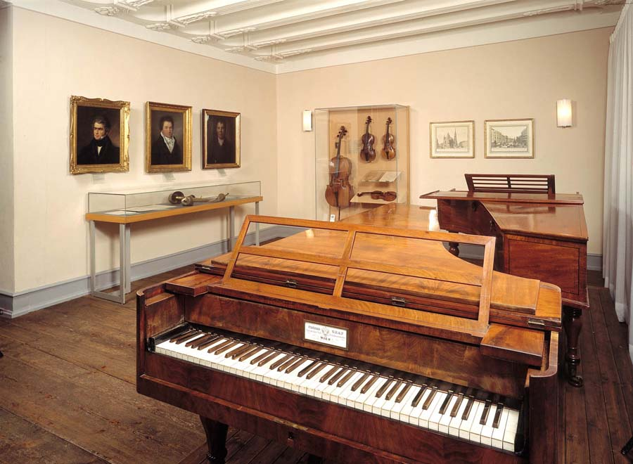

Image 6

Plaque outside the Beethoven – Haus in Bonn where Beethoven was born.

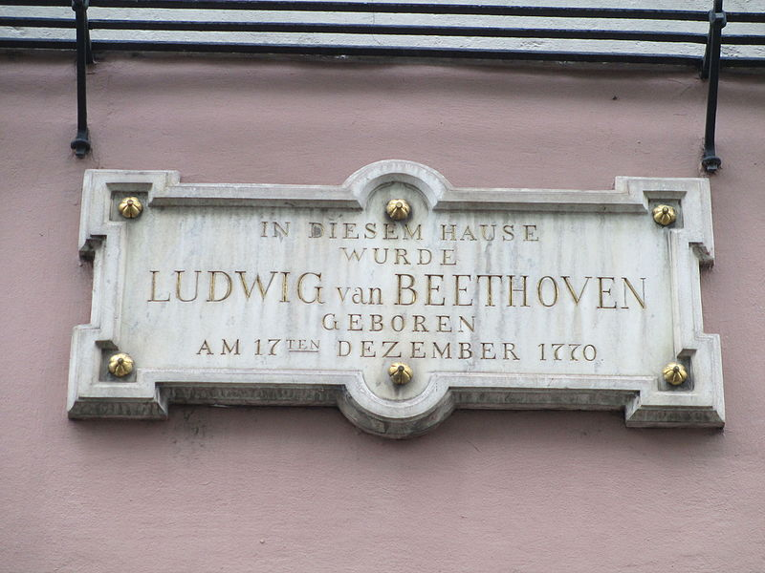

Image 7
Fidelio, playbill of the third and finalized premiere at the Kärntnertortheater in Vienna, 23 May 1814
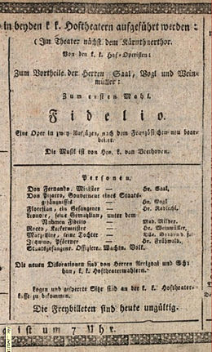
Image 8
Beethoven’s symphonic Homage to Nature.
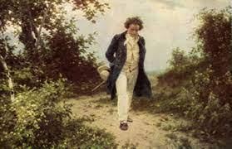

Author: Stephen Davis.
Date: 9.8.21
Words: 4,325

About the author:
Stephen Davis BA (Hons) is an established Classical Music Presenter, Medieval Calligrapher, Proof-reader, Criminologist, Criminal & Forensic Psychologist, Tudor and Shakespeare historian and graduate researcher in 20thC History at the University of Hull.

The Classical period (c1730 – 1820) was recognised as being the second of the established Common Practice (or Middle period) divisions of Western Art music, falling between the Baroque and Romantic periods, covering the time scale of around 1600 -1900.
Western Art Music. For more information on the history and influences of Western Art Music, please access and follow this informative web link and simply scroll down as appropriate: www.britannica.com/art/Western-music
Catalogue of Beethoven overtures composed between 1800 & 1822: https://www.henle.de/blog/en/2020/09/28/beethoven-creator-of-concert-overtures/
Common Practice. Missa Solemnis is a Mass setting of the time of “Common Practice”, consisting of a combination of musical arrangements, relating to the Baroque, Classical and Romantic subdivisions of the associated period (Timeline: 1600 -1910).
Neefe, Christian Gottlob. German opera composer and conductor. Neefe was born in Chemnitz, Saxony. He received a musical education and started to compose at the age of 12.
The Beethoven Collection. The complete Beethoven works are catalogued in Appendix 2 on p29 of this paper.
Hogler, Fritz (1901-1961) on Wolfgang Amadeus Mozart, (Vienna: Österreichischer Bundesverlag, 1956). N.B. The contents of this book are written in the Germanic language.
Solomon M., Beethoven: (London: Cassell & Colt., 1978). Life in Bonn, pp 3-53; Early years in Vienna, pp 57-103.
Davenport, M. Mozart (London: William Heinemann Ltd., 1933). A momentous moment when the 17-year-old Beethoven was introduced to the composer Mozart in Vienna, the meeting of which took place in the year 1787. Please refer to pp 218/219 of this book or more information.
Cooper, B. The Beethoven Compendium (London: Thames and Hudson, 1991). Barry Cooper, Musicologist & former Professor of Music at the University of Manchester, provides information on significant aspects of Beethoven’s life & music, including: Historical background, Portraits, Musical source material and looks at Beethoven as an individual, i.e. appearance and character. Please refer to page 50: Mozart: “Influences on Beethoven’s style”, pp 80-87; the inspiration of both Haydn & Mozart on p83.
Robbins Landon, H.C., Beethoven: A Documentary Study (London: Thames & Hudson Ltd,1970). Highlights. This book contains some beautiful black & white/ colour engravings of Beethoven and his contemporaries. Also included is a portrait of Napoleon Bonaparte, a rare image of the theatre in Vienna where Beethoven moved to in the year 1803 and a poster advertising the first ever performance of the opera FIDELIO on 20.11.1805, the information for which includes the names of the individual players and seat prices at the time of presentation.
Crowest, Frederick J., Beethoven (London: J M Dent & Co., 1903). Orchestration & instrumentation: The rise of the orchestra as established by Haydn & expanded by Beethoven. Also, the influence of Mozart’s instrumentation. pp 213-218.
Sipe, T. Beethoven: Eroica symphony (Cambridge: CUP, 1998). Of particular interest is Chap 3, pp 30-53, these being in dedication to the French Emperor and Statesman Napoleon Bonaparte.
Lockwood, L. Beethoven: Studies in the Creative Process. (Cambridge: Harvard University Press, 1992). Relevant study material: Chapter 4, Eroica Perspectives: Strategy and Design in the First Movement, pp118-133; Chapter 5 - specifically detailing Beethoven’s early sketches for the “Eroica symphony”, pp134-150.
Mies, P. Beethoven’s Sketches: an analysis of Beethoven’s style based on a study of his sketchbooks. (London, Constable & Co. Ltd., 1974). Reader: Please carefully study the following book contents: Part 2 - Beethoven as a creative artist & the importance of sketches, pp 147 – 161. Further reading ……… Please refer to the following two sections of the book: Part 1 (Style Determinants). Part 3 (Musical Expression), containing important information of specific interest.
Peter Takacs. The Mind of Beethoven. A performer’s perspective. Looking at selected studies into Beethoven’s ‘imaginative’ mind.
Further information on Therese Malfatti and Fur Elise can be found by accessing the following website: www.all-about-beethoven.com/beethovenmature.html
For more information on the Pastoral symphony, please see the following web link: www.all-about-beethoven.com/symphony6.html. Please note that this website also includes relevant information on a wide range of Beethoven material, examples being a full list of the symphonies and other compositions.
Huscher, Phillip, Ludwig van Beethoven. Symphony No. 6 in F Major, Op. 68 (Pastoral). Programme notes. Ref: Chicago symphony orchestra programme annotator since 1987. Link: https://cso.org › uploaded Files › 1_Tickets_and_Events › 061010_Progra...
BEETHOVEN HOUSE: The Beethoven House in Bonn, Germany, is a memorial site, museum and cultural institution. The house was founded in 1889 by the Beethoven-Haus association and the museum continuously researches the life and works of Ludwig van Beethoven. Address: Bonngasse 20, 53111 Bonn, Germany. For visiting purposes, please check the museum opening times as shown on their website, as depending on the season they are subject to change.
P.A. Scholes, Oxford Junior Companion to Music. (London: Oxford University Press, 1954). Beethoven: ‘Sketch and Conversation Books’. P36.
Friedrich Schiller (1759 – 1805). German poet, philosopher, playwright and historian. The lyric poem Ode to Joy was written in the summer of 1785 whilst Schiller was staying in Leipzig. The original publication date was 1786 and the poem was re- published in 1808.
Wagner, Richard, German composer, 1813-1883.
D.B. Levy, Beethoven: The Ninth Symphony (New York: Schirmer Books, 1995). Relevant reading: Chap 2, pp 18-46 (especially read pp19-38 which focus specifically on Beethoven’s “sketches”, these being included in the following section: “Sketches for the Ninth symphony”). Please also read Chap 4, pp 88-121, ‘The Ninth: The Choral Finale,’ which discusses the 4 movements in extended detail.
Cooper, Martin, Beethoven: The Last Decade (1817-1827) (London: Oxford University Press,1970. Relevant reading: Chap 18, The 9th symphony, pp276-348. Includes selected manuscripts.
Sullivan, J.W.N., Beethoven: His Spiritual Development (London: Unwin books, 1964). Please read as follows: Book 2, Chap 1, Beethoven’s Characteristics, pp 36-47; Chap 3, The Mind of Beethoven, pp 62-67.
Leonard, R.A., The Stream of Music (London: Hutchinson & Co., 1967). p130, para. 1
FIDELIO: The following website contains detailed information on the “Fidelio” storyline, along with an included catalogue of the opera’s principal characters: www.naxos.com/education/opera_libretti.asp?pn=&char=all...fidelio. Please access the following section: ‘A – Z of opera’.
Dr John Bokina is a professor in the department of political science and Public Administration at the Central Michigan University, Mount Pleasant, Michigan.
Robbins, H.C., (London: Oxford University Press, 1929). A highly recommendable information source textbook. Book contents: A combination of B/W and coloured engravings. Also featured is a rare image of the theatre in Vienna, the city where Beethoven went to live in 1803. A further essential characteristic of this book is a rarely seen copy of an advertisement poster for the first ever performance of the opera FIDELIO, displaying the names of the cast members along with the prices at the time. This production took place on 20.11.1805 at the Wien theatre.
For information on the Beethoven piano concertos, readers of this paper would be well advised to visit the following website: www.classicfm.com/composers/beethoven/guides/beethoven-piano-concertos/
The sonata was completed in 1801 and was dedicated the following year to the Austrian Countess Giulietta Guicciardi, who was a pupil of Beethoven.
See Graham Johnson’s notes (2000) on Ludwig Rellstab which are available to view in Appendix 8 of this paper.
Prince Karl Alois Lichnowsky (1761 – 1814). Born in Vienna, Lichnowsky was a leading supporter of the arts movement, and was himself a musician and composer, managing the household of the Imperial Austrian court in his capacity as chamberlain.
Stephen Davis: Federation of Recorded Music Societies. My own presentation to a live audience at St James Park Broadway, London on 14.6.16. The programme featured an informal discussion, along with a classic CD version of the Violin Sonata number 9, followed by further selected Beethoven works.
Daniel Tong: Beethoven’s violin sonatas. For more information on pianist Daniel Tong, please see the following related website link in appendix 9 of this paper. https://www.prestomusic.com/classical/products/8432723--beethoven-violin-sonatas-plus-vol-1
Edwin Fischer: Beethoven’s Piano Sonatas. The complete listings are available to view as follows: http://www.all-about-beethoven.com/pianosonatas.html. Edwin Fischer was a Swiss classical pianist & conductor (1886-1960). More Information on Edwin Fischer’s life is available to access on the obituaries page of the “Musical Times”, the details of which can be found in the catalogue of JStor articles as displayed at the end of this paper via the following appropriately named link: Stable URL: http://www.jstor.org/stable/948484.
Rodman, M. For information on the Beethoven violin concerto, please refer to the website as shown below. www.imslp.org/wiki/Violin_Concerto_in_D_major,_Op.61_(Beethoven,_Ludwig_van)
Salvatore Vigano. More information on his life can be found at the following website: https://www.britannica.com/biography/Salvatore-Vigano
When Beethoven announced his deafness. See the Ludwig van Beethoven biography which can be accessed at the following link: http://www.lvbeethoven.com/Bio/BiographyDeafness.html
Leonard, R.A., The Stream of Music (London: Hutchinson & Co., 1967). p135 para. 1 & 2.
Crowest, Frederick J., Beethoven (London: J. M. Dent & Co., 1903). pp 238 -240.
Crowest, Frederick J., Beethoven (London: J. M. Dent & Co., 1903). Conducting synopsis. pp 138-141.

